**Requirements Elicitation – Banking System**

**1. Functional Requirements**

The system should be able to:

-Provide personal and professional information to potential clients.

-Permit consumers to open accounts for savings, investments, or checks.

- Implement account-specific guidelines:

- Savings: There should be No withdrawals done.

-Investment: To open an account 500pula is needed.

-Employment information is required for the check.

-Permit money to be deposited in any account.

-Permit cash withdrawals from check and investment accounts.

-Compute and apply the interest each month:

-There should be 0.05% in savings

- Show each account's transaction history.

- Support several accounts for each client

2. **Non-Functional requirements:**

*Security: For data protection and authentication.

*Performance - Quick processing of interest and transactions should be done.

*Usability: There should be easy-to-use user interface for onboarding and account actions.

* Scalability: Should be able to accommodate several clients and accounts.

* Reliability: Precise interest and transaction records Should be done.

**REQUIREMENTS ELICITATION-BANKING SYSTEM**

**Interviewer**: Tlhalefo Mogote

**Interviewee**: Lecturer

**Date**: 18 September 2025

**Purpose**: To gather functional and non-functional requirements for the banking system assignment.

**Mock interview**

**1.  Should the system be able to handle login errors?**

Lecture’s response: Features would never work, only application matters. Focus is on the OO Concepts

**2. Since individuals have their own identification numbers, what do companies use as their own unique identification?**

Lecture’s response: Because they are all customers, what only differentiates them could be for the company.

3. **Should the system support multiple users**

Lecture’s response: It’s an issue of performance and shouldn’t focus much on it.

4**.What kind of currency should be used?**

Lecture’s response: Anyone can dictate on the currency they want to use.

**End of Interview........**

**Structural UML Modelling**

System Use Case Diagram

Class diagram

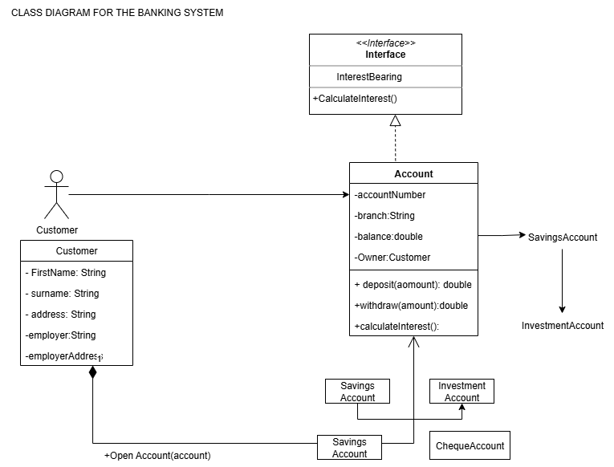

**BEHAVIOURAL UML MODELLING**

**SEQUENCE DIAGRAM**

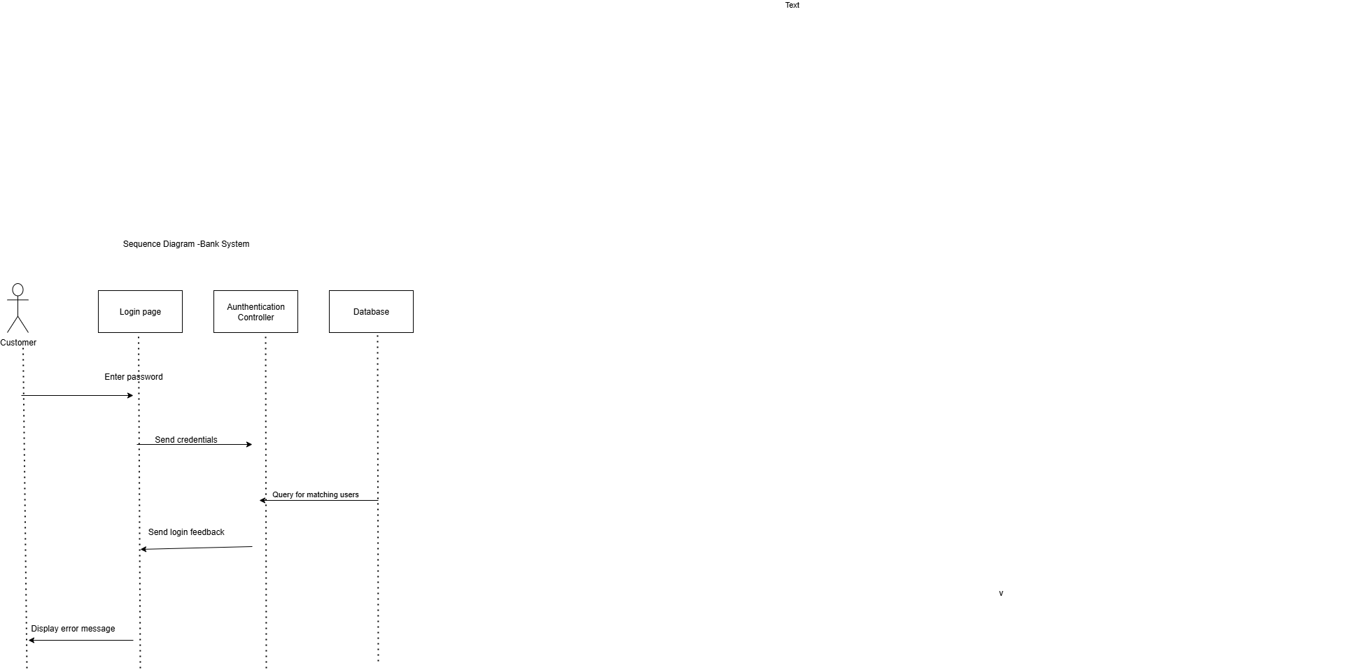

STATE DIAGRAM FOR PAYINTEREST





